

CS3211 Project Progress Report

Group 5

Ong Jit Sheng, Jonathan A0073924B

Tran Minh Hoang A0088452X

Le Vu Nguyen Chuong A0088552W

We have:

* Finish The CSP model for a deadlock free case that supports multi ATM to communicate with the cloud process and database process. We use synchronized actions for them to work in parallel.
* We have written assertion to check the system is deadlock free. And one assertion that if the ATM is successfully authorized, it is not guarantee that the money will come out.

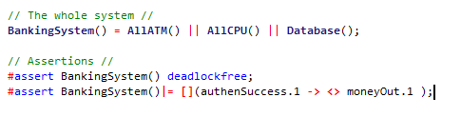

* The java code is being built although they are not completed yet.